**SQL SERVER-DAY-1**

**SQL Server** is a Relational Data Base Management System, or RDBMS, developed and marketed by Microsoft.

It supports a wide variety of transaction processing, business intelligence and analytics applications in corporate IT environments.

A database in SQL Server is made up of a collection of **tables** that stores a specific set of structured data. A **table** contains a collection of **rows**, also referred to as **records** or **tuples**, and **columns**, also referred to as **attributes**.

Q) What is Data?

Data is a Collection of RawFacts.

Data can exist in many forms like numeric, character, Audio file, Video file.

Q) What is DataBase?

A database is an organized collection of data, so that it can be easily accessed and managed.

Q) What is DBMS ?

A Database Management System (DBMS) is software designed to store, retrieve, define, and manage data in a database.

Q) What is RDBMS?

**RDBMS** is a software used to store, manage, query, and retrieve data stored in a relational database is called a relational database management system (RDBMS).

Q) How to interact with RDBMS?

To interact with SQL Server data base, you can use the **Transact-SQL** (T-SQL) language, an extension of the SQL standard.

Q) What is SQL ?

**SQL** stands for **Structured Query Language** · SQL lets you access and manipulate databases

**SQL** is a collection of predefined commands, keywords and syntax rules.

By using SQL, we can write English like statements, known as **QUERIES**.

**List of SQL COMMANDS in SQL SERVER**

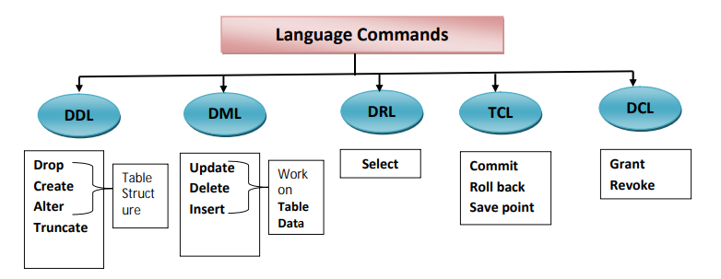

**HOW TO DOWNLOAD SQL SERVER ?**

Use below link to download SQL SERVER

<https://www.microsoft.com/en-us/sql-server/sql-server-downloads>

Download ***DEVELOPER*** edition.

**How to install SQL SERVER ?**

i) Double click on Screen Options and at last ***install SSMS*** also.

* **How to connect with SQL SERVER data base?**

we can connect to **SQL SERVER** database by using **SSMS** [ Microsoft SQL Server Management Studio].

Follow the below Procedure.

1. Launch Microsoft SQL Server Management Studio.  
   START--> PROGRAMS-->MICROSOFT SERVER TOOLS--> Select **Microsoft Sql server Management Studio**
2. The Server type should be Database Engine.
3. Enter the server name.
4. Authentication is SQL Server Authentication Or Windows Authentication.  
   **If you select windows authentication, then no need to enter username and password, go to step 7.**

**If you select SQL SERVER AUTHENTICATION, then go to step-5**

1. Enter your database username.
2. Enter your database password.
3. Click Connect.

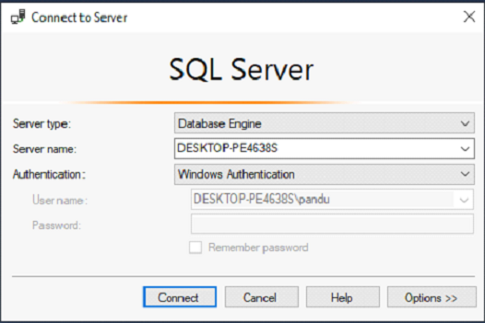

**Sever type:**

This Property is used to select the service that we want to work.

**SSIS:**

SQL Server Integration services. It is used to integrate different data Sources, using a data warehouse tool. ETL() (Extract/Transfer/Load).

**SSAS:**

SQL Server Analysis Services. It is used to analyze data.

**SSRS:**

SQL Server Reporting Services. ‡To report.

**Server name:** It is used to mention the name of System where Database server is installed.

Server name may be Computer name/ IP Address etc.

Authentication: It is a process of checking user credentials.

User credentials means username and password

Once connected, we can see the below Environment.

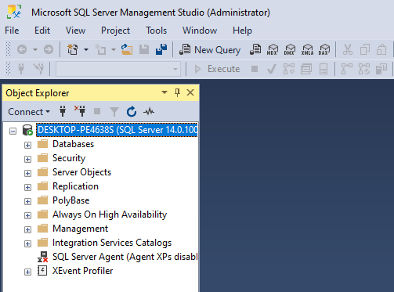

**System databases in SQL Server**

SQL Server contains four System Databases (master, model, msdb, tempdb).

Each of them is used by SQL Server for Separate purposes.

From all the databases, master database is the most important database.

**Master Database**

* Master Database contains information about SQL server configuration. Without Master database, server can’t be started.
* This will store the metadata information about all other objects (Databases, Stored Procedure, Tables, Views, etc.) which is Created in the SQL Server.
* It will contain login information of users.

**Model Database**

* The model database sets a template for every database that was newly created.
* It serves as a template for the SQL server in order to create a new database.
* When we create a new database, the data present in model database are moved to new database to create its default objects which include tables, stored procedures, etc.

**Msdb**

* The msdb database is used mainly by the SQL server Management Studio, SQL Server Agent to store system activities like sql server jobs, mail, service broker, maintenance plans, user and system database backup history.

**TempDB**

* Whenever the SQL server starts, the Tempdb is created by using model database in the form of a template.
* By default, it does not contain any data.
* The tempdb is a temporary location for storing temporary tables (Global and Local) and temporary stored procedure that hold intermediate results during the sorting or query processing and cursors.